**Assignment 2 - Git**

**Commands used to accomplish the Tasks:**

[ec2-user@ip-172-31-9-153 gitdemo]$ history

1 git --version

2 sudo hostctl hostname-set gitdemo

3 sudo status hostctl hostname-set gitdemo

4 mkdir gitdemo

5 cd gitdemo

6 git initi

7 git init

8 sudo git init

9 sudo apt install git

10 sudo yum install git

11 git --version

12 git init

13 git branche

14 git branch

15 ls

16 branch

17 git branches

18 git status

19 git log

20 git branch

21 git b

22 git -b

23 nano feature1.tx

24 nano feature1.txt

25 nano feature2.txt

26 ls

27* git com

28 git add -a

29 git add .

30 git status

31 git commit -m "commiting feature1 and feature2.txt"

32 git config --global --edit

33 git config --global user.name "csushm03"

34 git config --global user.email "csushma138@gmail.com"

35 git commit -m "commiting feature1 and feature2.txt"

36 git branch

37 git checkout -b develop

38 git checkout -b feature1

39 git checkout -b feature2

40 git branch

41 git checkout develop

42 ls

43 git checkout feature1

44 ls

45 git checkout feature2

46 ls

47 git checkout develop

48 nano develop.txt

49 git status

50 git stash develop.txt

51 git stash

52 git stash -u

53 git checkout feature1

54 nano new.txt

55 ls

56 git status

57 git add .

58 git commit -m "commiting new.txt file"

59 git status

60 git checkout develop

61 git stash list

62 git stash pop

63 git add develop.txt

64 git commit -m "commiting develop.txt on develop branch"

65 history

[ec2-user@ip-172-31-9-153 gitdemo]$

Created the four branches – feature1, feature2, develop and master and commited the relevant files under each branch.

Committed feature1.txt ad feature2.txt files in master branch

Created develop.txt under develop branch and stashed it.

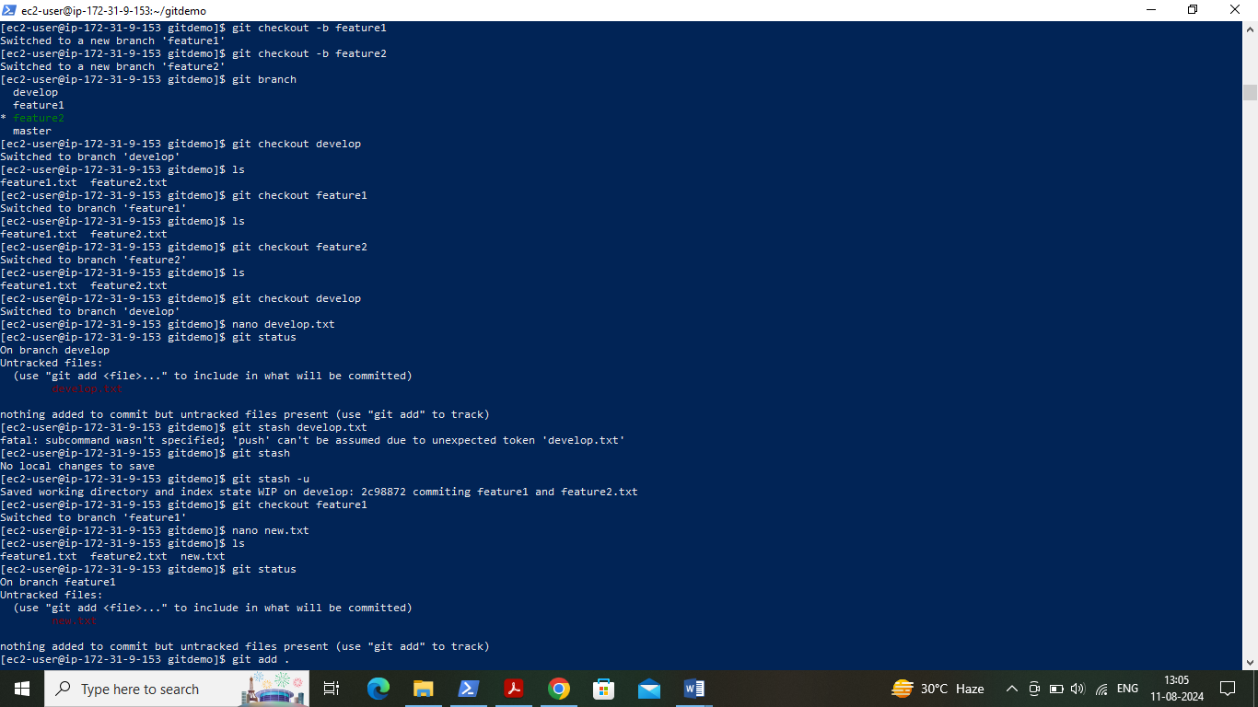

Created new.txt file in feature1 branch and committed it. Popped the stashed file on develop branch and committed it.

